**MIAKRYLICS.COM – The Design Process**

**Miakrylics - Documentation**

**Added Features**

To improve the service we finally opened up booking for hand nail services. Unfortunately Combos and Feet services are still unavailable for the client. The pricing is also calculated using JavaScript (with SessionStorage) when the end-user goes on to book the service, creating an object to store the service name, price and selected addons. These requested addons are added to the final price displayed to the user. Due to technical issues with the backend, the site cannot currently accept payment and so the form does not enable users to input their card details (for safety reasons).

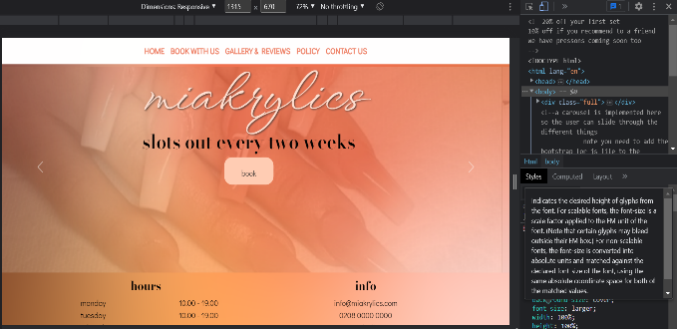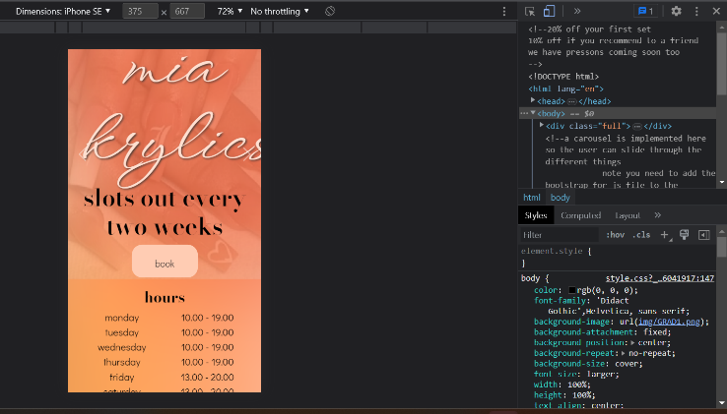To provide guidance for our customers, the website references an article on how best to take care of acrylic nails[1]. This is incorporated into the carousel in the homepage, which provided a bit of dynamic to engage the end-user. Additionally, the entire site incorporates more mobile friendly UI due to the use of bootstrap container classes. These were tested using the Google Developer Tools to confirm that the breakpoint conditions were written correctly, whilst easing the way in which different screen sizes were tested with the site. This is seen in the diagram below.

The responsivity here is also included in the navigation bar. Once the user’s device becomes a certain size the navigation bar becomes a “hamburger-menu” which is a bit easier to navigate on smaller (vertical phone type) devices.

**Evaluation**

In the previous implementation the user was actually unable to book a service but that has been updated. Ideally, all three service types would be available, however, to be able to book services is quite a step from having a basic video tutorial for how to remove acrylic nails. Theoretically, the fact that the booking form has validation checks adds a level of security to the user and client experiences: users should not able to book between certain times, and they should be required to input their name for their booking. However this was not implemented effectively within this website. The name and date variables are required but the button still works if the name and email fields are blank. However, using JavaScript I was able to set up the page such that you cannot confirm your appointment unless you actually pick a date (although the user can select Sunday 3am, which they should not be able to do). Nonetheless, there is a level of validation included in the website for Miakrylics.

The use of Bootstrap in the updated website, compared to in the previous implementation, assisted the overall aesthetic of the website, for example this package enabled the use of carousel and card classes, whilst also easing the creation of a responsive user interface.

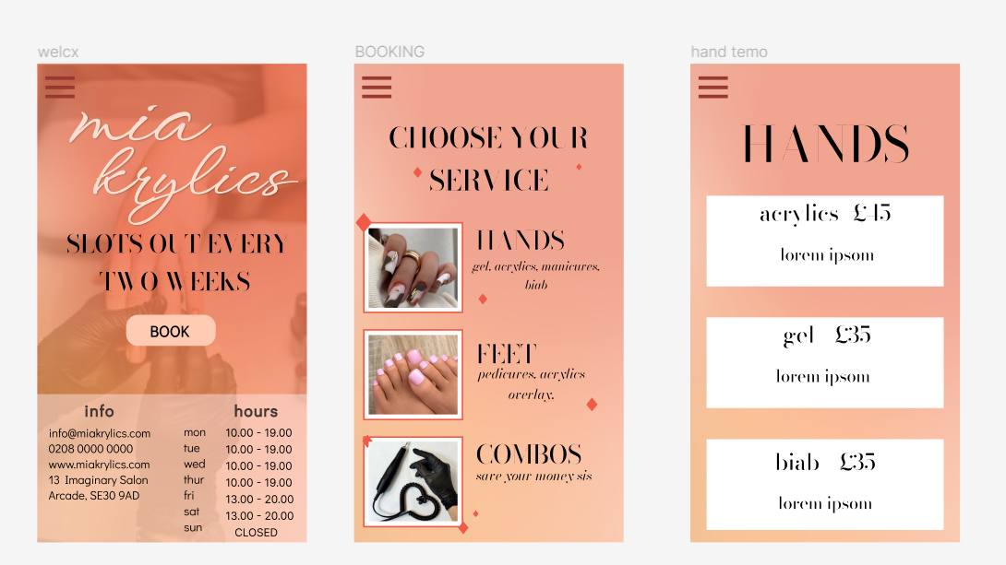During the redesign process, I decided to take on a mobile first type approach. This involved me developing wireframes using Figma first for a phone screen (ratio 9:16) and then mimicking the design onto a larger screen. This can be seen below.

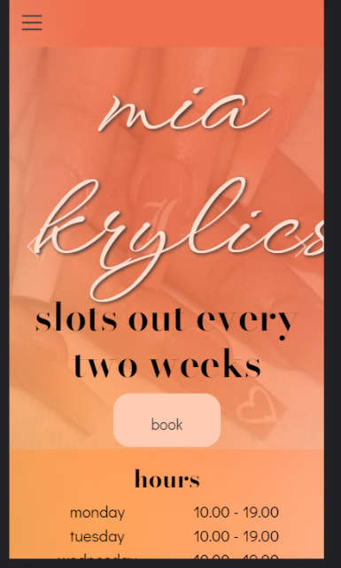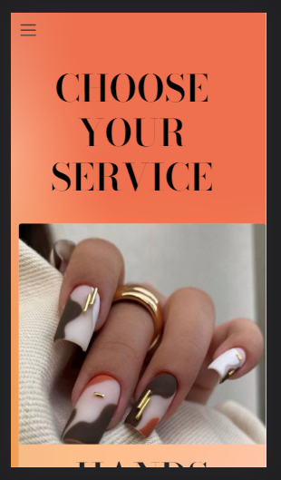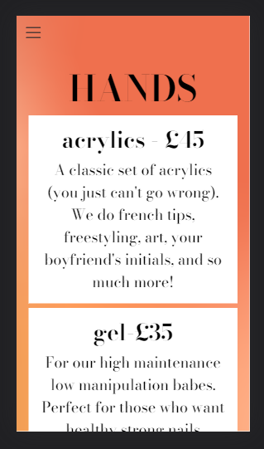

The use of Figma was especially convenient as it allowed me to make wireframes with similar designs to the actual website, making the actual site creation process a lot smoother. In some instances one may even have thought the Figma wireframes were the actual website footage, but on inspection they do have their differences.

In my design I did not account for the space taken up by descriptions, hence the difference between the hand service boxes. However I did notice with the service selection I would need to make the card such that the image was on top rather than to the side, as this was less visually taxing to convert to desktop screen dimensions - on a large 1920x1080 screen there would be a lot of empty space if the service selection looked just like that of the wireframe.

Another improvement made to the layout of this page is the fact that the booking button on the home page no longer takes the user to the policy before taking them to actually book the service. This navigation was somewhat confusing, and whilst it forces the user to read the terms an conditions before booking, it proved inefficient and frustrating for those who were already familiar with Miakrylics’ terms of service. This is why that navigation pathway was cut. The end user can still however, read the policy for themselves as it is located in the navigation bar.

Essentially, the website has had quite an upgrade since the first build: both in terms of the functionality and the layout of said website. Regardless, it would be beneficial to use better validation tactics to make the site more suited to all end-users’ needs.

**Responsive and Accessibility testing**

Initially this website was designed only considering one size of screen type. I went back and redesigned it with consideration for phone users, using Google Dev tools for testing. Most responsive layout was applied using Bootstrap breakpoints, however for the navigation bar styling a media query was included stating that when the screen becomes wider than 768px the navigation bar should be white with orange text. Outside of these conditions the navigation is collapsible with white text.

To test for validation I used the w3c validation service, inputting all my HTML and CSS pages into the checker. They all came out valid with zero errors, meaning that my pages should all validate. I also used the web accessibility evaluation tool to check the WCAG level on my pages. The one consistent error in my code was that I had an “invisible” button for my navigation bar. However this is only invisible until the user’s screen gets small enough. Aside from this, the colour contrast on my pages was good on all pages apart from the homepage. This was due to the images used in the carousel and the brown subtext used. To improve my accessibility, I could make my images more transparent or use white text with a dark brown outline. This will ensure the text is readable for all, rather than it being aesthetically pleasing yet incomprehensible.

**References**

1. <https://nestnailwellness.com/blog/take-care-acrylic-nails/>

**Images on Miakrylics website:**

1. Logo: NXADESIGNS, Ann-Marie Lartey, February 2023
2. (Pinterest, 2023) https://i.pinimg.com/originals/9a/b3/f5/9ab3f5e52d5e2393b451b4daf323bcaf.jpg
3. (Pinterest, 2023) <https://i.pinimg.com/originals/58/73/6c/58736c8540926318fb9d6ce431ded92d.jpg>
4. (Pinterest, 2023) <https://i.pinimg.com/originals/d9/93/de/d993de6fc322e8772126ea25c64485ed.jpg>
5. (Pinterest, 2023) https://i.pinimg.com/originals/92/f1/84/92f18482fbb752bc8782b827ec5c0a4b.jpg
6. (Pinterest, 2023) <https://i.pinimg.com/originals/25/f2/5f/25f25ff6c72507d457bae20db1cb9307.jpg>
7. (Pinterest, 2023) https://www.pinterest.co.uk/pin/837247386996685577/
8. (Pinterest, 2023) https://www.pinterest.co.uk/pin/731412795739144736/
9. (Pinterest, 2023) <https://www.pinterest.co.uk/pin/837247386996716726/>
10. (Instagram, @nailedbyjl, 2023) https://www.instagram.com/p/CetJZ70sPU8/?igshid=MDJmNzVkMjY%3D&epik=dj0yJnU9YmlLNVB0cWg5TVlZUnY2ZnFLekdOQmVzOXFfeFN3TjYmcD0wJm49b1Q0MlZ0WjgxMHBHY3pPR0hrNVpNUSZ0PUFBQUFBR1Jnb09N

1. https://nestnailwellness.com/blog/take-care-acrylic-nails/